**API Aplikasi Inventaris**

Untuk mengakses api ini kamu butuh headers dengan key authorization dan value token.

Token bisa kamu dapetin dengan melakukan Auth, untuk Authnya saya menggunakan jwt(json web token).

berikut untuk lebih jelasnya :

|  |  |  |
| --- | --- | --- |
| Methods | Endpoints | Details |
| POST | /login | Get token and data login user.  request key : username and passowrd |

ERD :

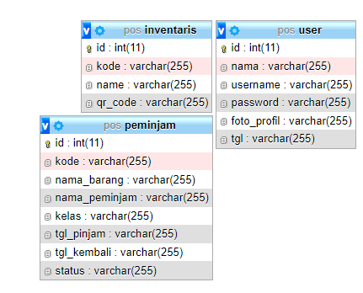

Endpoint table inventaris :

|  |  |  |
| --- | --- | --- |
| Methods | Endpoints | Details |
| GET | /inventaris | Get all inventaris |
| GET | /inventaris/1 | Get inventaris with id = 1 |
| POST | /inventaris | Insert new inventaris.  request key : kode, name, qr_code |
| PUT | /inventaris/1 | Update data inventaris where id = 1.  request key : kode, name,qr_code |
| DELETE | /inventaris/1 | Delete inventaris where id  = 1 |

Endpoint table peminjam :

|  |  |  |
| --- | --- | --- |
| Methods | Endpoints | Details |
| GET | /peminjam | Get all data peminjam |
| GET | /peminjam/2 | Get data peminjam with id=2 |
| POST | /peminjam | Insert new peminjam.  request key : kode, nama_barang, nama_peminjam, kelas |
| PUT | /peminjam/2 | Update data peminjam with id=2.  Request key : kode, nama_barang, nama_peminjam, kelas |
| DELETE | /peminjam/2 | Delete data peminjam with id=2 |
| GET | /kembali/2 | Change the field status data peminjam to ‘kembali’ |